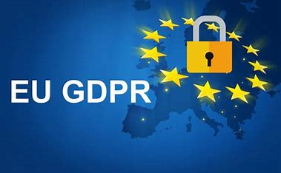

Data Protection Notice

This Practice complies with the General Data Protection Regulation 2016 and the Data Protection Act 2018.

WE use your Information to provide you with Health Care services, and share you information with other organisations involved in your care.

The practices does this under Article 6(1) and Article 9(2)(h) of the GDPR.

For further information see ask to see a copy of our Privacy Notice (also available on our website) or a copy of the leaflet “How we use your information”

You are entitled to see what information we hold about you on request

